Exception hierarchy:

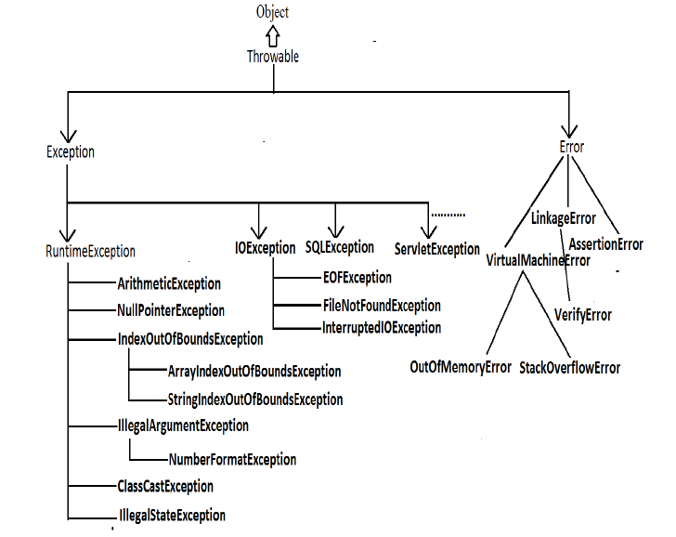

**public** **class** NestedExceptionDemo123 {

**public** **static** **void** main(String[] args) {

**try** {

**int** i = 40 / 0;// / by 0

} **catch** (ArithmeticException ae) {

System.***out***.println("exception occured");

System.***out***.println(ae);

**int**[] inn = **new** **int**[5];

**try** {

inn[20] = 55; // ArrIndexOutOfBoundException

} **catch** (ArrayIndexOutOfBoundsException are) {

System.***out***.println("exception occured");

System.***out***.println(are);

inn[4] = 55;

**try** {

inn[20] = 55; // ArrIndexOutOfBoundException

} **catch** (ArrayIndexOutOfBoundsException arde) {

System.***out***.println("exception occured");

System.***out***.println(are);

inn[4] = 55;

}

}

}

}

}

**public class NestedTryCatchDemo {**

**public static void main(String[] args) {**

**int i = 10;**

**int j = 0;**

**try {**

**int k = i / j;// devide by 0 exception**

**} catch (ArithmeticException a) {**

**System.out.println("Exception occured");**

**System.out.println(a);**

**}**

**System.out.println("outside try catch block code executing smoothly");**

**System.out.println("hello");**

**try {**

**// array declaration**

**int[] in = new int[5];// [1,2,3,4,5]**

**in[20] = 52;**

**}catch(ArrayIndexOutOfBoundsException ai) {**

**System.out.println(ai);**

**System.out.println("ArrayIndexOutOfBoundException handled");**

**}**

**System.out.println("after 1 ");**

**System.out.println("after 2 ");**

**System.out.println("after 3 ");**

**/\***

**\* in[0] = 5; in[1]= 6; in[2]=8; in[3] = 6; in[4] = 100;**

**\*/**

**// ArrayIndexOutOfBoundException : Index 20 out of bounds for length 5**

**}**

**}**

**public class NumberFormatexceptionDemo {**

**public static void main(String[] args) {**

**String str = "142345556";**

**try {**

**long longqw = Integer.parseInt(str);**

**System.out.println(longqw);**

**}catch(NumberFormatException nfe) {**

**System.out.println("nfe exception has occured");**

**System.out.println(nfe);**

**}**

**}**

**}**